FMOL ​Assistant
​ ​

(v3.2xx)​​​

The FMOL Assistant uses Pass-through Authentication for general AD connections. It does not use Pass-through Authentication for Finesse since some users logging into different queues.

Looking up a User
You can look up a user by using the Spyglass on the Main Window. Many different ways of searching are available.
Search types:
- FirstName LastName
- FistName M LastName
- LastName, FirstName
- LastName, FirstName M
- Username
- Lawson#
Uncheck ‘Exact Match’ if you wish to view a list of users to choose from. With this option unchecked, you can search by partial names or usernames.
- W/o Exact Match example1: der du
- W/o Exact Match example2: du, de
  - These examples will pull up a list of all users that match these criteria. Including myself (Derrick Ducote).

​Main Window and Features

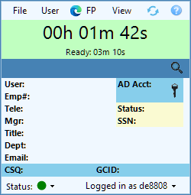

Finesse Timer
The top half of the Main window is the Finesse Timer. This will display Talk Time as well as other Finesse Status times.
- This Timer will change from Green to Red after extended time Talking or Not Ready.
- It will also ‘Blink’ at different intervals to notify you of being on Not Ready.

User Information
The second half of the Main window is the User Information section. This will display all of the caller’s information or any user you choose to lookup.
- User information is populated based on the Lawson # a customer enters when calling into the Help Desk.
  - The CSQ and GCID are also pulled in from the call data.
- You can manually lookup a user using the Spyglass to the right.
  - Review the section on looking up users for more details.
- User account status is first pulled from MIM, then all other data is pulled from AD.
  - If the account is not in MIM, it may still find the AD information.
Features:
- Right Clicking
  - Gives you the option to clear the window.
- Double clicking text
  - This will copy the text to the Clipboard.
  - Copying the SSN will copy it as ‘Tempxxxx’.
- Double click Mgr
  - Open Manager Details in place of current user.
- Double click Tele
  - Open Dialpad with the telephone number.
AD Tools:
- The AD Acct Expiration Date
  - Hovering over the date will show how much time is left to Expiration.
  - Double clicking the date will allow you to manually Expire the password.
  - Accounts with an exclamation ‘(!)’ have past the Expiration date.
  - If not set or expired, the AD Acct will show ‘Expired’.
- The AD Acct Key
  - Click the black key to reset an AD password.
  - If the key is yellow, click the key to unlock the account.

Toolbar
The top Toolbar contains various useful tools.
- File
  - Preferences
    - Edit application preferences.
  - Close Window
    - Keeps the FMOL Assistant running in system tray.
  - Exit FMOL Assistant
    - Closes entire application.
- User
  - FP History
    - Launches Footprints History (FP11 only)
  - AD Groups
    - Opens window to search Top Level and Nested AD Groups.
    - Gives options to Add/Remove groups.
  - View Employee Details
    - Opens an Assistant Browser with Prov Employee Details.
  - View Role Based Access
    - Opens an Assistant Browser with Prov RoleBase.
  - Edit Lawson Profile
    - Opens an Assistant Browser with MIM Employee Details.
  - [SCCM] PC
    - Gathers the user’s last logged on PC from SCCM if available.
    - If available, clicking this toolbar will copy to clipboard.
    - The SCCM PC will not be available to many users using Tap n Go.
- FP
  - New FP Ticket
    - Opens new FP ticket with current user information.
  - Internet Explorer (FP11)
    - Launches or uses Footprints with IE11.
  - Chrome (FP11 or FP20)
    - Launches Footprints in managed instance of Chrome.
  - Edge (FP11 or FP20)
    - Launches Footprints in managed instance of Edge.
- View
  - Call History
    - Opens a window with Finesse Status and Call logs.
  - Dialpad
    - Opens a Dialpad in place of User Information.
  - Marquee
    - Opens a Marquee.
  - Photo
    - Opens a Photo of the user from AD
  - Computer Toolkit
    - Opens a Toolkit used for Computers and Printers.
- Refresh
  - Reloads the data for the current user.
- Help
  - Reset Size
    - Resets the Main Window size back to default.
  - Show/Hide Border
    - Shows a proper window border if required.
  - Check for Updates
    - Checks for new updates in T: drive location.
  - About
    - Shows About data and update logs.

Status Bar
The bottom Toolbar contains your Finesse connection status.
- Status DOT
  - Allows you to change your Finesse status.
- Logged in as
  - Allow you to change accounts or re-login to Finesse.

Main Preferences

FMOL Assistant Preferences
- Enhancements
  - Do SCCM PC Lookup on All User Searches.
  - User Animation (Fading/Sliding)
    - Faster Animation
- Other
  - Show Tray Tip on Status Changes
  - Launch Photo Window on Start
  - Launch Marquee on Start
- Footprints
  - Open Existing Ticket if Available
  - Open New Ticket with Call
  - New Ticket Settings
    - Ticket Owner, Urgency, and Type.
    - Ticket Size – Width, Height, Center screen.
- Auido Dings
  - Audio Dings are Wrap-Up notifications.
  - These can be set as 3 separate notifications at different times during the Wrap-Up status. Used to keep you informed before switching to Ready.
    - Set Sound
    - Set Three optional times
    - Set relative volume
- Hotkeys
  - Answer an incoming call
    - Default Hotkey is “Ctrl+`”
  - Make call using selected text
    - Default Hotkey is “Ctrl+x”
    - You can choose to send the number to the Dialer or call the number instantly.

Photo Window
The Photo Window will display the photo of your user. The photo is pulled from AD and slightly resized. This window and be moved and ‘snapped’ to the Main Window.
- You can ‘un-snap’ the Photo Window in the Preferences.

Call History
This Call History window will show all logs saved while using the FMOL Assistant. You can search for specific types of status including (but not limited to) Lunch, RNA, Direct Call, Dropped Call, etc.
Features include:
- Right click to copy a field.
  - Copying a phone number will reformat it to 888-888-8888.
- Double click on Lawson.
  - This will open the user details in the Main Window.
- Double click on Phone.
  - This will send the phone number to the Assistant’s Dialpad.
- Double click the GCID.
  - This will attempt to locate and open the related Footprints ticket.

Dialpad
The Dialpad temporarily replaces the user information on the Main Window. From here, you can type or click a number to send Finesse and place a call.
- A default shortcut to make a call is “Ctrl+x”.
  - Highlighted text must contain a phone number or extension.
  - Any amount of text can be selected when clicking the shortcut.
  - The number formatted number will be sent to the Dialpad.
    - Preferences can be set to directly dial the number instead.

Marquee
The Marquee window contains FMOL Help Desk call data from Inova. The main portion of the window shows queues, statuses, and totals. The lower portion contains Footprints information.
Features include:
- Audio notification for extended Call Waiting times.
- Marquee Preferences. (lower right cogwheel)
  - Here you can view the Audio notification thresholds.
  - You can also change the notification sounds and relative volume.
  - You can also switch between two types of Marquee.
    - WallBoard Marquee
      - (Based on wallboard in Sherwood building.)
    - Assistant Marquee
      - (Based on older wallboard marquee.)
  - The option for swapping Phys and Supp queue is here as well.
- The scrolling Marquee text has information based on current FP Globals.
  - It can also contain messages from management.

Computer Toolkit (Printer Info)
The Computer Toolkit can be found on the View menu or from the Taskbar. This will open a replacement to the older Remote Toolkit. From here, you can lookup both computer and printers. The Computer Toolkit is a separate app that is found in you FMOL Assistant install location. It can be ran without the FMOL Assistant.
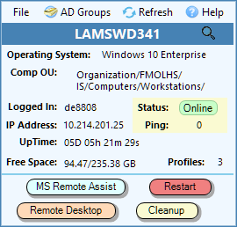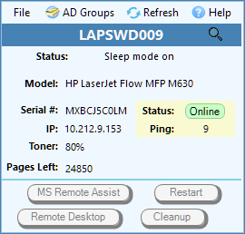
Note: The UpTime is accurate. If UpTime is not what is expected; it could be one of two things.
- Time change could affect this data.
- Windows Fast Startup could affect this data.
  - If someone uses ‘Shutdown’ on Windows 10; it works as Hibernation.
  - Using Restart or turning off Fast Startup is the only way to properly restart a Windows 10 workstation.

Toolbar
The top Toolbar contains various useful tools.
- File
  - Close Toolkit
- AD Groups
  - Opens window to search Top Level and Nested AD Groups.
  - Gives options to Add/Remove groups.
- Refresh
  - Reloads the data for the current user.
- Help
  - Reset Size
    - Resets the Main Window size back to default.
  - Show/Hide Border
    - Shows a proper window border if required.
  - About
    - Shows About data and update logs.

Main Window
The Main Window contains all the data gathered from the PC or Printer.
- Lookup a device:
  - Computer Name
  - Printer Name
  - IP Address
- Computer search will gather data after a successful Ping.
  - It may require you to type your -a account credentials.
- Printer search will gather data from the Web interface.

- Computer tools:
  - MS Remote Assist
    - Connect in with MSRA.
  - Remote Desktop
    - Connect in with MSTSC.
  - Restart
    - Send a remote restart command.
  - Cleanup
    - Run a custom cleanup script.
    - Or Copy the script to the remote C drive.

Cleanup Script
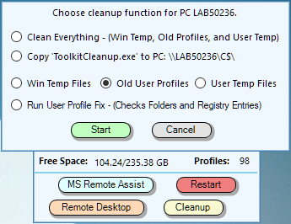
The Cleanup script has multiple options when running.
- Clean Everything
  - Cleans Windows Temp, Old Profiles, and remaining User Temp files.
  - This will deep clean all non-essential and non-user files from the pc.
  - It will remove all profiles that are un-modified after 2 months.
- Copy ‘ToolkitCleanup.exe’ to PC
  - This will save a copy of the cleanup script to the remote computer.
  - You can then run this script from the client’s pc for faster results.
- More Options
  - Allows you to run individual types of cleanups on the computer.
    - Only Clean Window Temp Files
    - Only Delete Old User Profiles
    - Only Clean User Temp Files
  - Run User Profile Fix
    - Resolve login issues with user profiles.
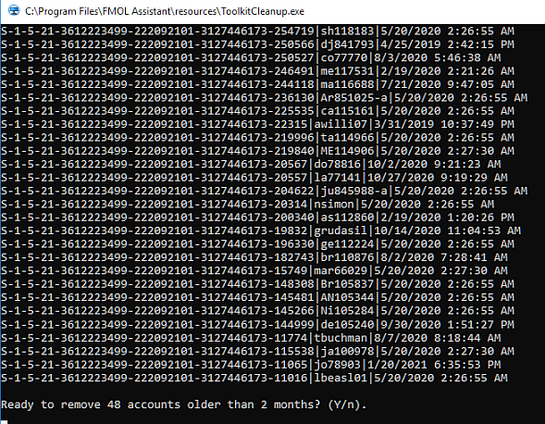

User Profile Fix
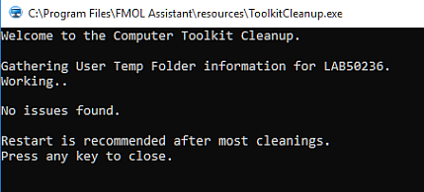
The ‘User Profile Fix’ option was added to resolve login issues.
Example issue: Customer is getting a Temporary desktop when logging in on Non-Tap n Go.
Probable Issue Cause: Customer’s profile was removed but registry key was left in-tact.
The Fix will compare all User Registry keys with existing user folders. It then removes the troublesome keys that do not have associating folders. And renames the folders that do not have associating keys.

Troubleshooting
Since version 3.2.1, the FMOL Assistant will automatically attempt to send a crash report to derrick.ducote@fmolhs.org. This report will only contain small details on the exact error. If running in Debug mode, the report will contain a more detailed report.
If you are experiencing any type of regular (day-to-day) crashing, please run the FMOL Assistant using Debug Mode. A shortcut to this can be found on your start menu or inside of the application’s install location. Or manually run the Assistant with -debug switch.
While running in Debug mode, the application will write a few details to a Debug.txt file. You can send that file to derrick.ducote@fmolhs.org to attempt to help resolve the issue.

If you can find the steps to replicate any crashing that occurs, please don’t hesitate to let us know.

